صورة تحتوي على نص

تم إنشاء الوصف تلقائياً

MCT 4334

Embedded System Design

**Assignment**

Comparative Analysis of Microcontrollers, Microprocessors, and Embedded Systems in Mechatronics

Semester 2, 2023/2024

 Written by:

HESNAWI MOHAMAD 1836065

SECTION 1

1. Introduction

In mechatronics, we use embedded systems to blend mechanical, electrical, and computing parts. Microcontrollers and microprocessors are like the brains of these systems. Microcontrollers are small computers built into a single chip, while microprocessors are the main brains of regular computers. They are important because they enable automation, control, and communication in mechatronic systems.

1. Microcontrollers

According to Ibrahim (2014) “A microcontroller is a single chip computer, Micro suggests that the device is small, and controller suggests that the device can be used in control applications. Another term used for microcontrollers is embedded controller, since most of the microcontrollers in industrial, commercial, and domestic applications are built into (or embedded in) the devices they control.”

* 1. **Architecture and Features**

Microcontrollers typically integrate a CPU, memory (RAM and ROM), input/output ports, timers, and serial communication interfaces onto a single chip, as can be seen in Figure 1. They are designed for real-time embedded applications, offering low-power consumption and cost-effectiveness.

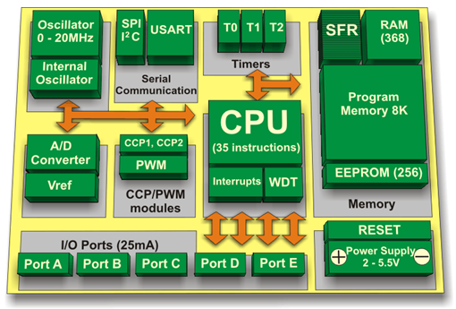

Figure.1 Microcontroller Architecture (PIC Microcontroller Architecture and Advantages | CPU, RAM and ROM, 2015)

* 1. **Applications**

Microcontrollers have extensive use in mechatronics, like powering devices such as industrial automation systems, robotics, automotive control systems, and consumer electronics. For example, in robotic arms, microcontrollers manage motor control, sensor interfacing, and feedback mechanisms.

* 1. **Advantages and Limitations**

Advantages of microcontrollers include their compact size, low power consumption, and suitability for specific applications. However, they may have limited processing power and memory compared to microprocessors, restricting their applicability in more complex systems.

1. Microprocessors

According to Daintith and Wright (2008) a microprocessor is “a semiconductor chip, or chip set, that implements the central processor of a computer.”

* 1. **Architecture and Features:**

Microprocessors are standalone CPUs designed for general-purpose computing tasks. They require external memory and peripheral chips to function, as can be seen in Figure 2, offering higher processing power and flexibility compared to microcontrollers.

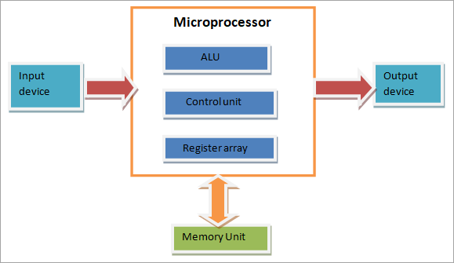

Figure.2 Microprocessors Architecture (What Is a Microprocessor [Basic Concepts of Microprocessors], n.d.)

* 1. **Applications:**

In mechatronics, microprocessors are utilized in systems requiring complex computations, such as image processing in autonomous vehicles, control algorithms in advanced robotics, and simulation software in engineering applications.

* 1. **Advantages and Limitations:**

Microprocessors excel in tasks requiring high computational power and flexibility. They offer scalability and compatibility with a wide range of peripherals. However, they consume more power and may incur higher costs compared to microcontrollers because the extra components the need to operate like the memory unit.

1. Comparison between Microcontrollers and Microprocessors

Microcontrollers and microprocessors are both essential components in embedded systems, but they differ in their architecture, capabilities, and application areas.

1. **Architecture:**
   * Microcontrollers typically integrate with a CPU core, memory ,both RAM and ROM/Flash, input/output peripherals, timers, and other components into a single chip. They are designed for specific tasks and are often used in embedded systems where cost, power consumption, and size are critical factors.
   * Microprocessors, on the other hand, focus mainly on processing power. They require external support chips such as memory, I/O controllers, and peripherals to function. Microprocessors are more versatile and powerful than microcontrollers and are commonly used in applications such as personal computers, servers, and high-performance computing systems.
2. **Processing Power:**
   * Microprocessors generally offer higher processing power compared to microcontrollers due to their focus on computational tasks. They are suitable for handling complex algorithms and multitasking operations.
   * Microcontrollers have limited processing power compared to microprocessors but are sufficient for many embedded applications. They are optimized for specific tasks and real-time operations.
3. **Memory:**
   * Microcontrollers typically have integrated memory (ROM/Flash for program storage, RAM for data storage) on-chip. The memory size may vary depending on the specific microcontroller model.
   * Microprocessors rely on external memory components such as RAM, ROM, and storage devices like hard drives or solid-state drives (SSDs). This allows for more flexibility in memory expansion but may increase system complexity and cost.
4. **Peripherals:**
   * Microcontrollers often include a variety of on-chip peripherals such as analog-to-digital converters (ADCs), digital-to-analog converters (DACs), UARTs, SPI, I2C, GPIOs, PWM, etc. These peripherals facilitate interfacing with external sensors, actuators, and communication devices.
   * Microprocessors may require separate peripheral chips or modules for interfacing with external components. While this offers flexibility in choosing specific peripherals tailored to the application, it also increases system complexity and cost.
5. **Cost:**
   * Microcontrollers are generally more cost-effective than microprocessors due to their integrated design and fewer external components required for operation.
   * Microprocessors may incur higher costs due to the need for additional support chips, external memory, and peripherals.

Table.1 summary of differences between microcontrollers and microprocessors

|  |  |  |
| --- | --- | --- |
| Aspect | Microcontrollers | Microprocessors |
| Architecture | Integrated CPU, memory, and peripherals on a single chip | Separate CPU with external memory and peripherals |
| Processing Power | Lower processing power | Higher processing power |
| Memory | Integrated memory (ROM/Flash, RAM) on-chip | Requires external memory components |
| Peripherals | Integrated peripherals (ADC, UART, SPI, etc.) | May require separate peripheral chips/modules |
| Cost | Generally lower cost | May incur higher cost due to external components |
| Size and Integration | Compact size and integrated design | May require more board space due to external components |
| Power Consumption | Optimized for low power consumption | May consume more power |
| Development Complexity | Simplified development with tailored IDEs and libraries | More complex development, especially in configuration and software management |

1. Impact on Embedded System Design in Mechatronics:

The choice between a microcontroller and a microprocessor significantly affects the design and functionality of an embedded system in mechatronics:

1. **Performance vs. Cost:**
   * Microprocessors offer higher performance but at a higher cost compared to microcontrollers. In mechatronics applications, where real-time processing and precise control are often required, the trade-off between performance and cost needs to be carefully considered.
2. **Integration and Size:**
   * Microcontrollers, with their integrated design, are more suitable for compact and space-constrained mechatronic systems. They simplify PCB layout and reduce overall system size and weight.
   * Microprocessors may require more board space due to the need for additional external components, which can be a concern in small-scale mechatronic designs.
3. **Power Consumption:**
   * Microcontrollers are optimized for low power consumption, making them ideal for battery-operated or energy-efficient mechatronic systems.
   * Microprocessors may consume more power, especially when running complex algorithms or multitasking operations, which could be a consideration in portable or energy-constrained applications.
4. **Development Complexity:**
   * Microcontrollers often come with integrated development environments (IDEs) and software libraries tailored to their specific architectures, simplifying the development process.
   * Microprocessors may require more complex software development, including the configuration of external peripherals and memory management, which can increase development time and effort.
5. Case Studies

**Case Study 1: Smart Door System by Obande et al (2014)**

**System Overview:**

This System is designed to enhance security and convenience. It integrates mechanical, electrical, and software components to create an intelligent door control mechanism.

**Components Used:**

1. **Microcontroller (PIC 16F877A)**:
   * **Rationale**: The choice of a microcontroller stems from its suitability for real-time control tasks. The PIC 16F877A offers several advantages:
     + **Integrated Peripherals**: It includes built-in analog-to-digital converters (ADCs), timers, and communication interfaces.
     + **Low Power Consumption**: Ideal for battery-operated systems.
     + **Cost-Effective**: The PIC microcontroller is budget-friendly.
     + **Ease of Programming**: Flowcode programming software simplifies coding.
   * **Functionality**:
     + Reads sensor inputs (e.g., motion sensors, door position sensors).
     + Controls the servo motor for door movement.
     + Communicates with other components.
2. **Servo Motor**:
   * **Rationale**: The servo motor provides precise angular control for opening and closing the door.
     + **Feedback Mechanism**: Servos have built-in feedback (position sensing) that ensures accurate door positioning.
     + **Compact Size**: Fits well within the door frame.
     + **Compatibility**: Easily interfaced with the microcontroller.
     + **Reliability**: Servos are robust and durable.

**Case Study 2: Autonomous Unmanned Aerial Vehicle (UAV)**

**System Overview:**

The Autonomous UAV is a sophisticated drone equipped with sensors, GPS, cameras, and communication modules. Its purpose is to perform various tasks autonomously, including surveillance, mapping, and package delivery, without human intervention.

**Components Used:**

1. **Microprocessor (Cortex-A7)**:
   * **Rationale**: A power-efficient processor designed for devices with varying requirements.
   * **Functionality**: Balances power and performance, making it suitable for UAVs hosting rich OS platforms.
2. **Sensors**:
   * **Inertial Measurement Unit (IMU)**: Measures acceleration, angular velocity, and orientation. Crucial for stabilizing the UAV.
   * **GPS Receiver**: Provides accurate position information for navigation and waypoint-based missions.
   * **Cameras (RGB and/or Depth)**: Capture visual data for computer vision tasks (e.g., object detection, tracking, and mapping).
3. **Actuators**:
   * **Brushless Motors**: Control propellers for flight manoeuvres.
   * **Servo Motors**: Adjust camera angles or payload release mechanisms.
4. Conclusion

In summary, microcontrollers and microprocessors are like the brains of embedded systems in mechatronics. Microcontrollers are small and built-in, perfect for tasks like controlling robots or household devices. They are cost-effective and use less power. Microprocessors, on the other hand, are more powerful but need extra parts to work. They're great for tasks needing a lot of computing power, like running software on computers or drones.

Choosing between them depends on factors like cost, power usage, and how complex the task is. Both are crucial for making mechatronic systems work smoothly, from smart doors to autonomous drones. They're driving innovation in technology and making our lives easier.

1. References

Ibrahim, D. (2014, January 1). *Chapter 1 - Microcomputer Systems* (D. Ibrahim, Ed.). ScienceDirect; Newnes. https://www.sciencedirect.com/science/article/abs/pii/B9780080999241000010

*PIC Microcontroller Architecture and Advantages | CPU, RAM and ROM*. (2015, August 20). Electronics Hub. <https://www.electronicshub.org/pic-microcontroller-architecture/>

Daintith, J., & Wright, E. (2008). A Dictionary of Computing. : Oxford University Press. Retrieved 7 Mar. 2024, from <https://www.oxfordreference.com/view/10.1093/acref/9780199234004.001.0001/acref-9780199234004>.

*What Is A Microprocessor [Basic Concepts of Microprocessors]*. (n.d.). Www.softwaretestinghelp.com. <https://www.softwaretestinghelp.com/what-is-a-microprocessor/>

Obande, J., Rabiu, G., & Galadima, J. (2014). *Building Of Smart Systems Using Mechatronic Engineering: A Case Study Of “Smart Door” System*. *16*(5), 78–84. https://www.iosrjournals.org/iosr-jce/papers/Vol16-issue5/Version-6/L016567884.pdf